**Assignment 5**

**Disk Management**

Launch virtual machine in the cloud , attach 20 GB EBS volume

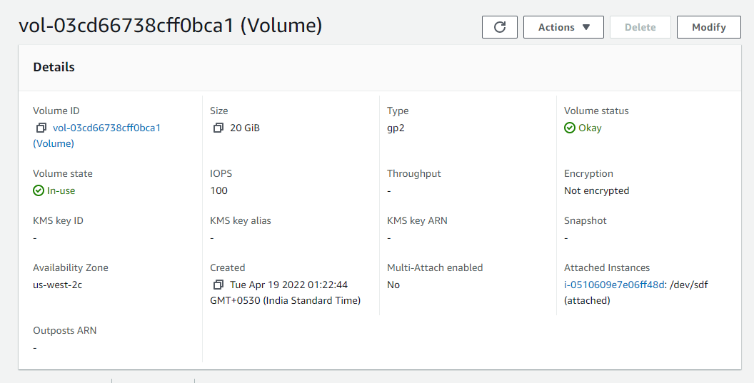

Create partition on newly attached disk as per below instructions –

1. Create 2 primary partitions of 3 GB each

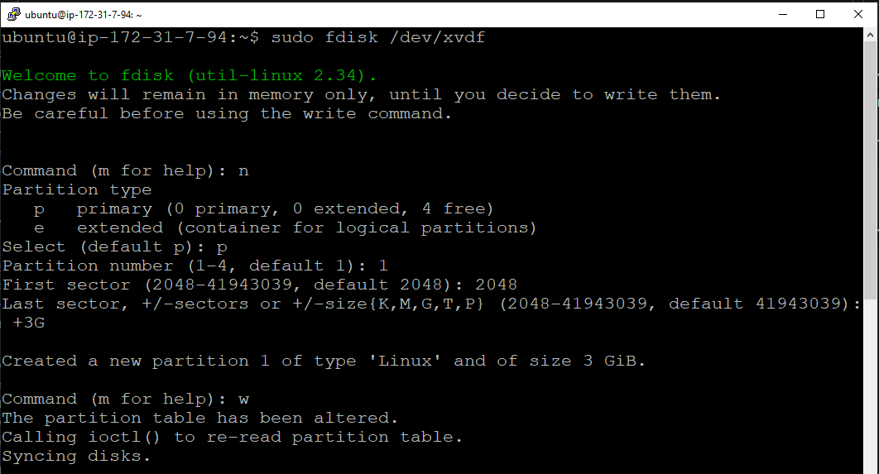

Commands :

sudo fdisk /dev/xvdf :- creating partitions in dev

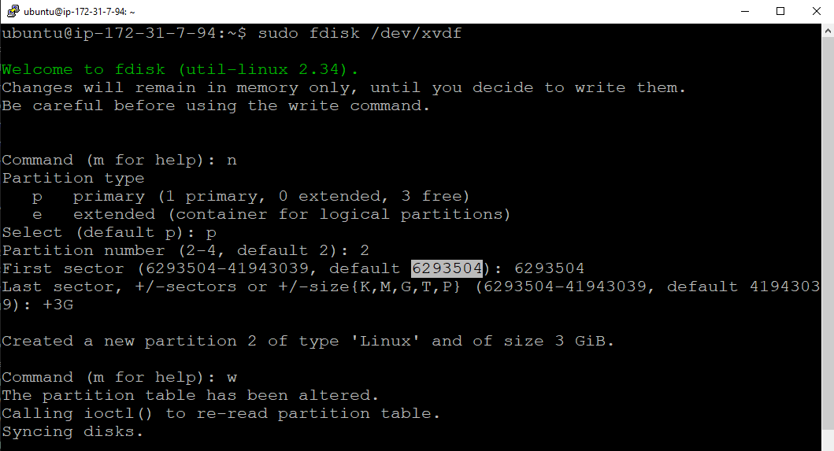

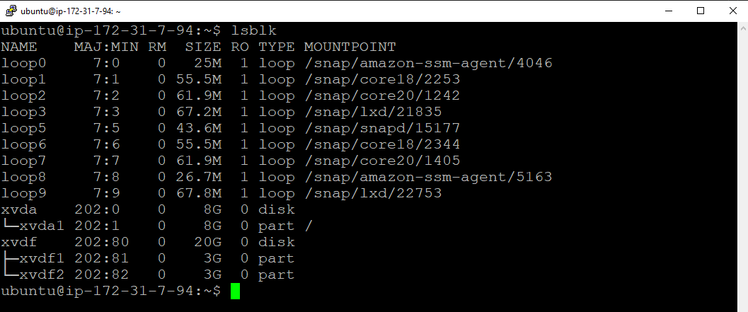

Commands :

lsblk :- checking partition details

1. Create 2 logical partitions of 6 GB each

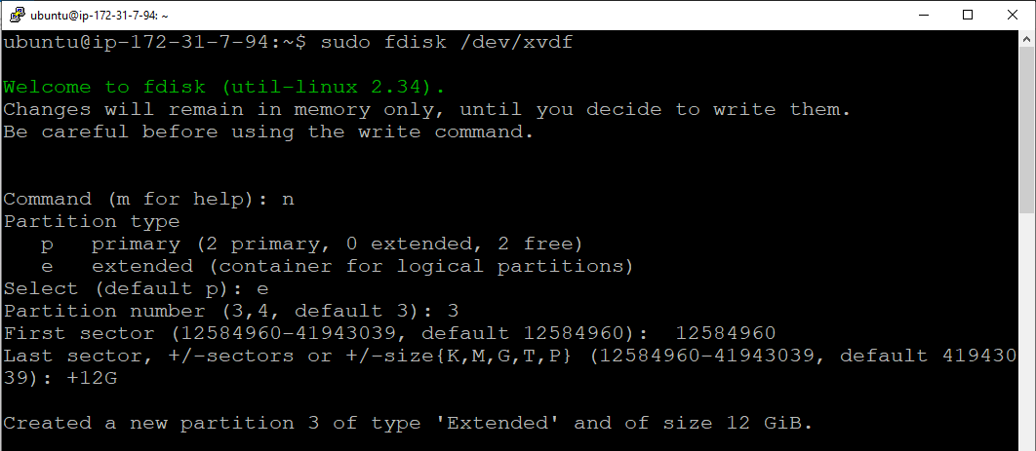

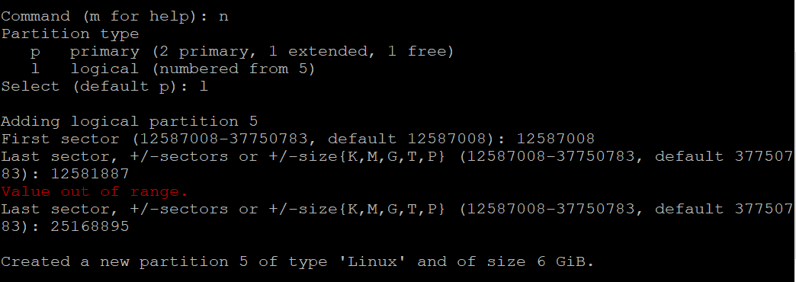

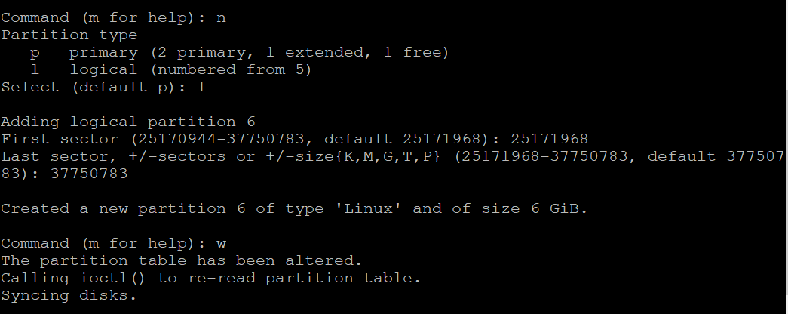

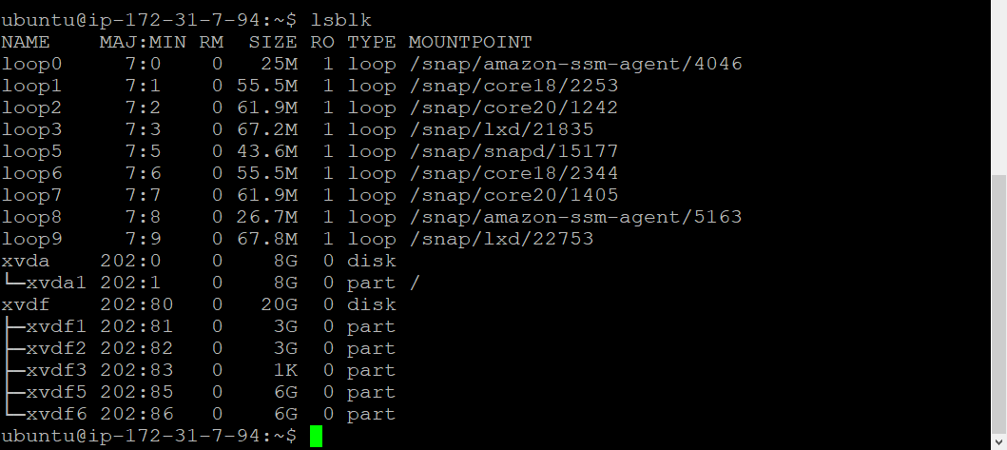

1. Format all 4 partitions and create ext4 filesystem on that

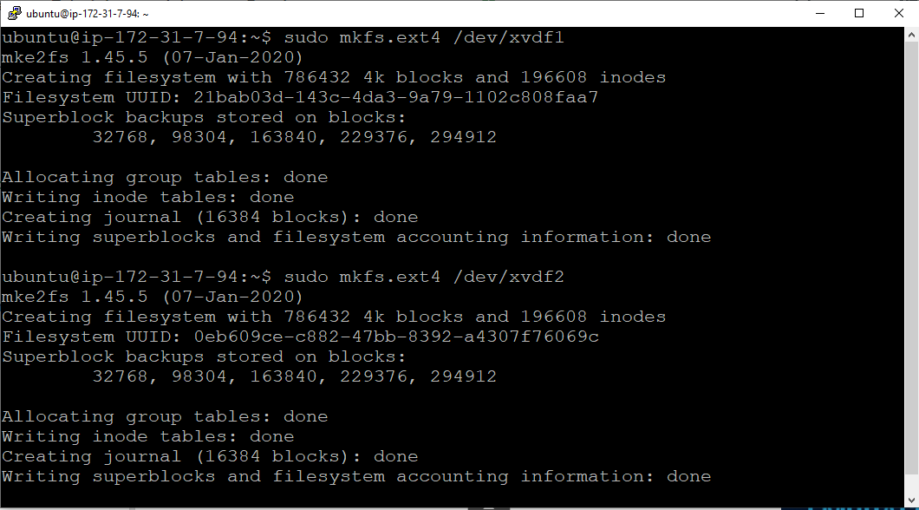

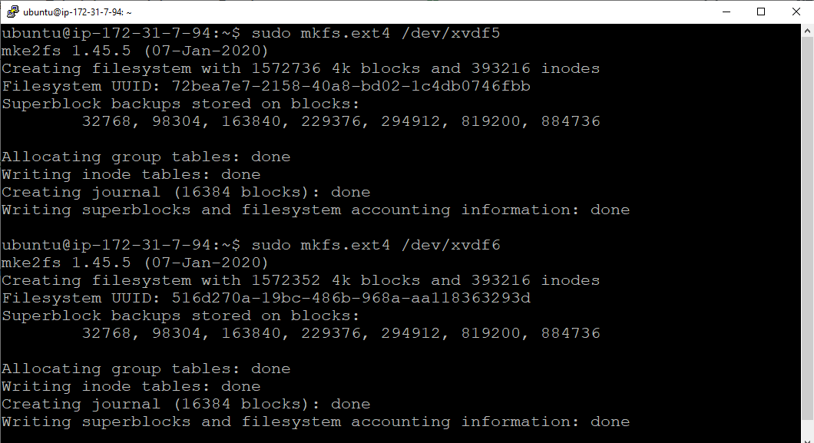

Command :

sudo mkfs.ext4 /dev/xvdf1 :- create file system ext4 and formatting partitions

1. Create 4 folders inside root ( / ) folder name it as Data1, Data2, Data3, Data4

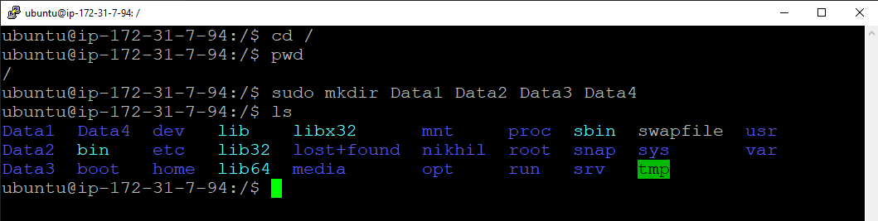

Command :

Mkdir Data1 Data2 Data3 Data4 :- creating directories

1. Mount all formated partitions on the respective folders

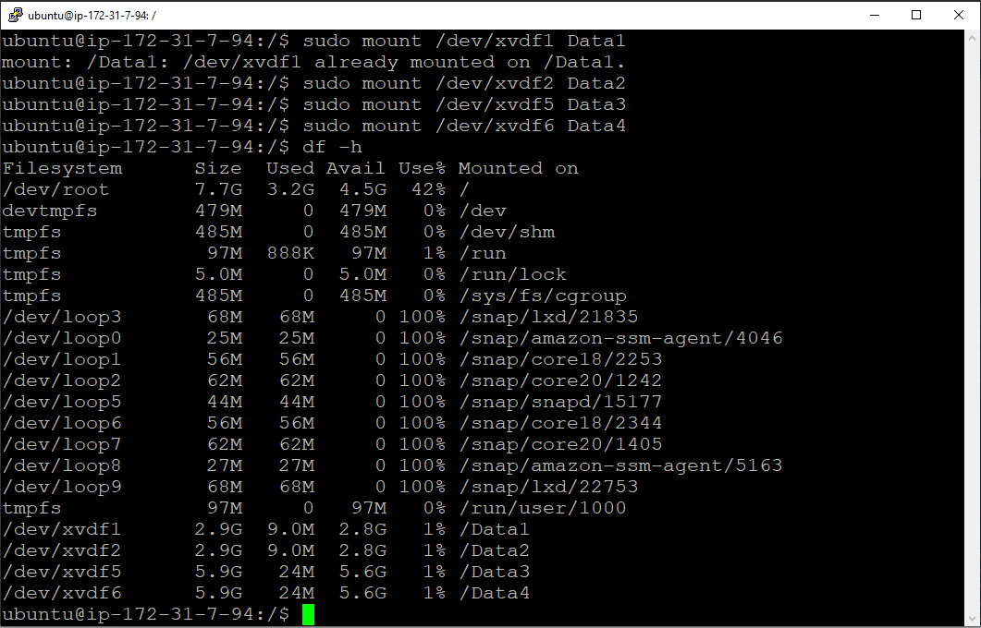

Command :-

sudo mount /dev/xvdf1 Data1 :- Mouting all partitions in each Data directories

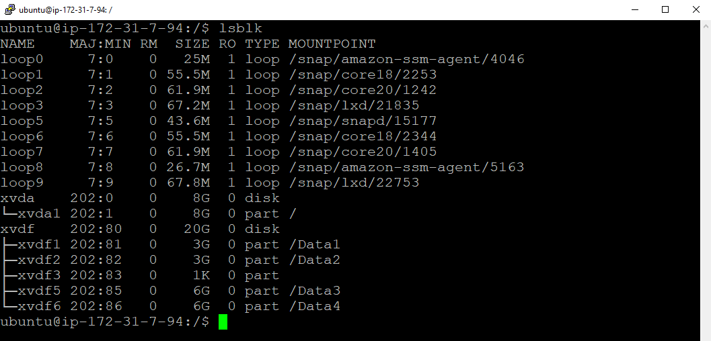

Commands :

lsblk :- Verifying data partition details

1. Create empty file inside each folders of size 2 GB, 2GB, 4 GB and 4 GB respectively  using  command -  dd - "convert and copy a file"

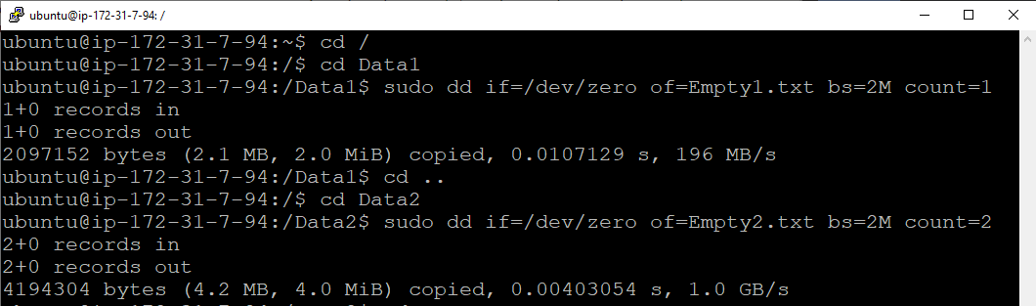

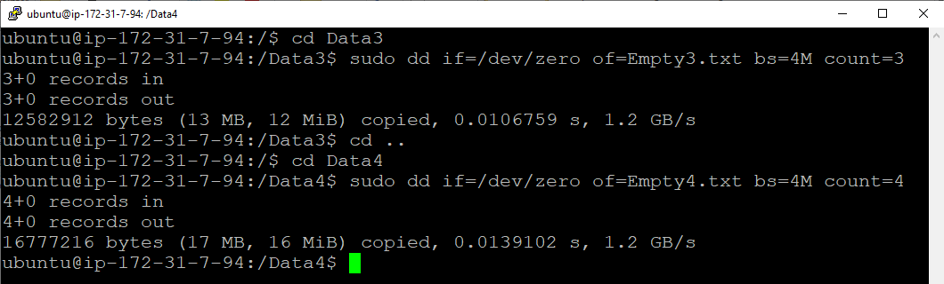

Commands :-

sudo dd if=/dev/zero of=Empty1.txt bs=2M count1 :- creating empty file with 2MB size

1. Go inside /Data1  and run  command -  while(true); do sleep 5s; done  , do ctrl+z

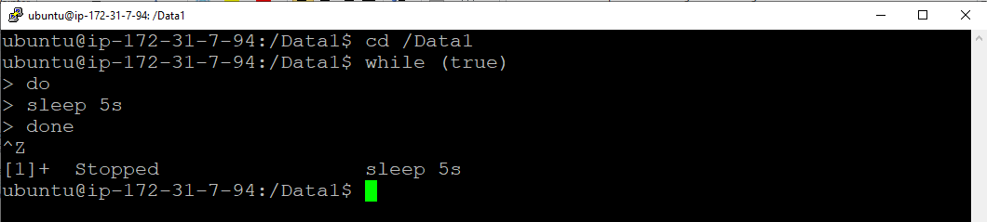

1. Check disk utilization of each mount point

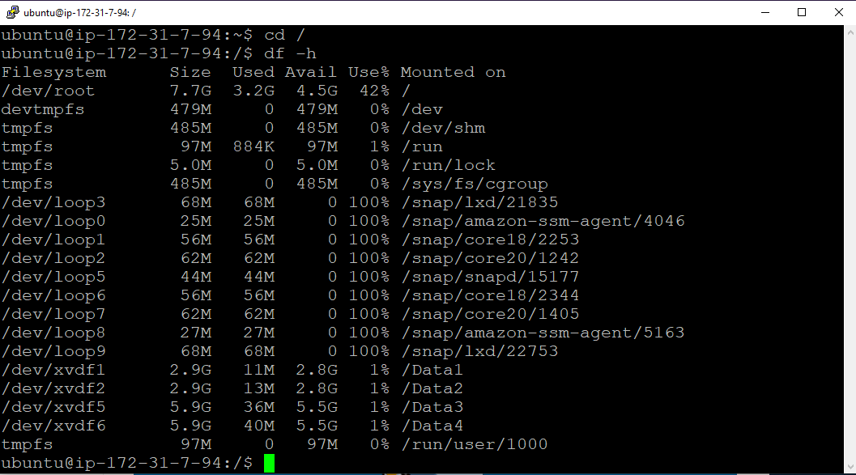

Commands :

df –h :- checking of disk usage of each directory

1. Unmount all partitions /Data1, /Data2, /Data3 and /Data4



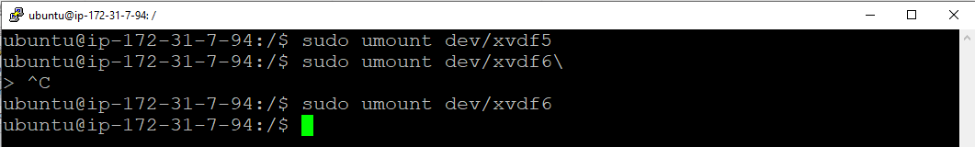

Commads :

sudo umount dev/xvdf1 :- Unmount the partitions from Directories

